PROJECT 1

Vishal Pathare| Intro. To DBMS

# Database Setup

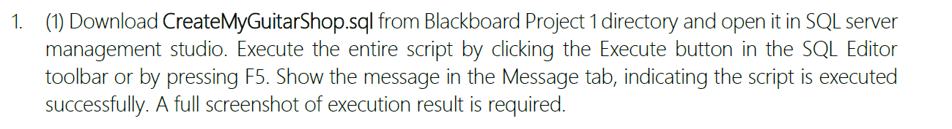

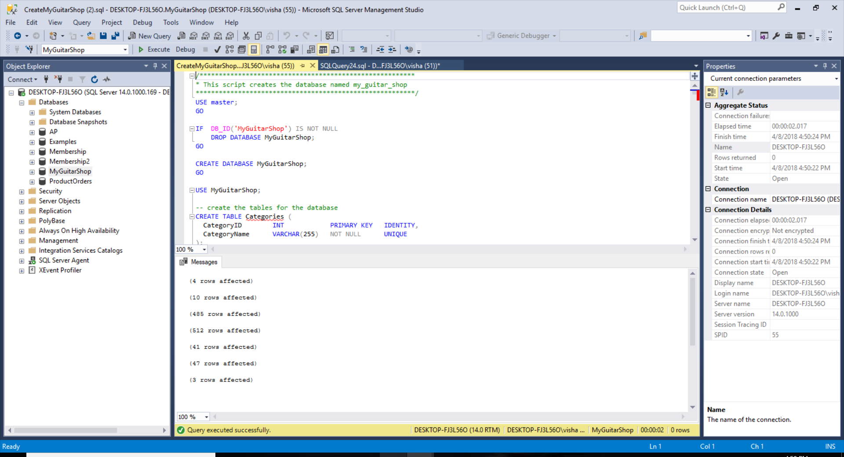

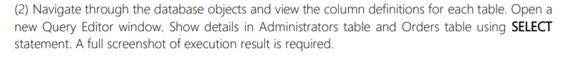

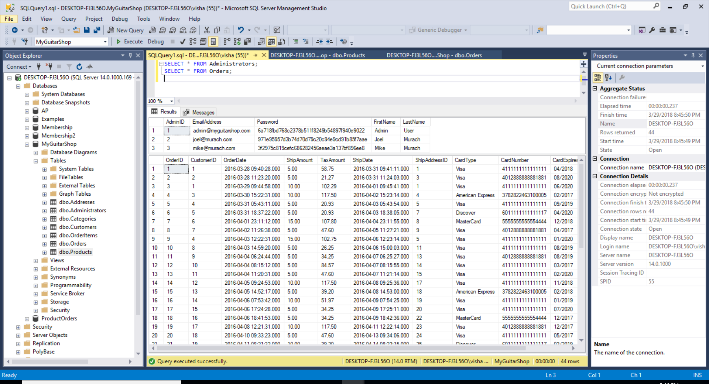

SELECT * FROM Administrators;

SELECT * FROM Orders;

## An Introduction to SQL

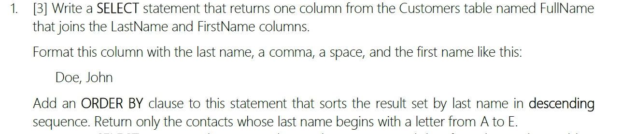

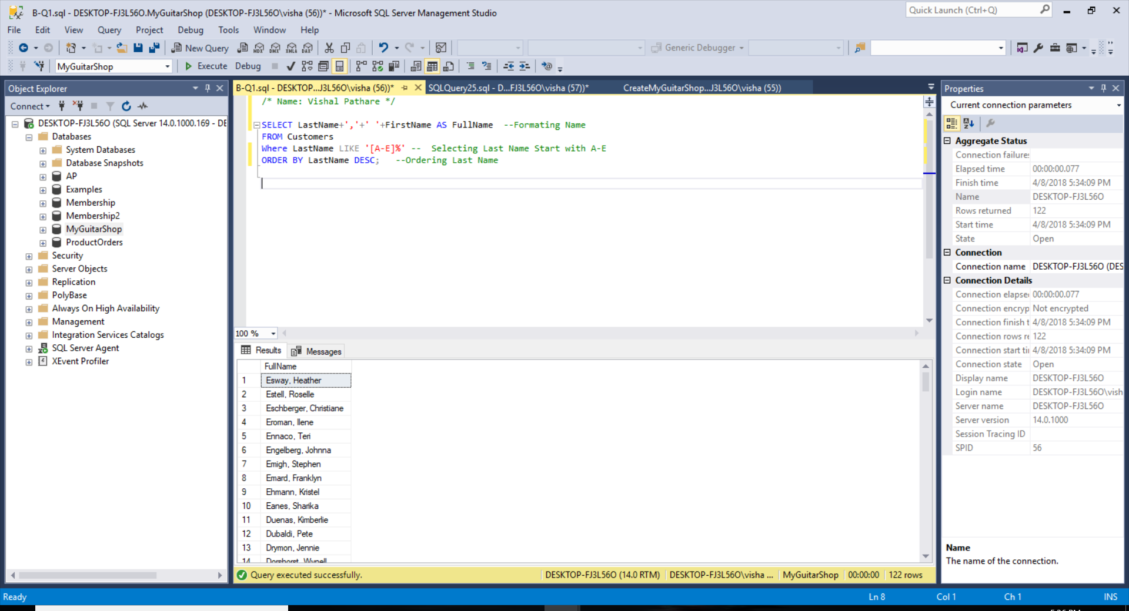

SELECT LastName+','+' '+FirstName AS FullName --Formating Name

FROM Customers

Where LastName LIKE '[A-E]%' -- Selecting Last Name Start with A-E

ORDER BY LastName DESC; --Ordering Last Name

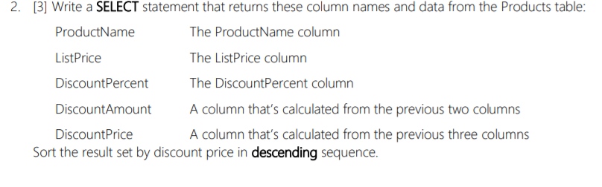

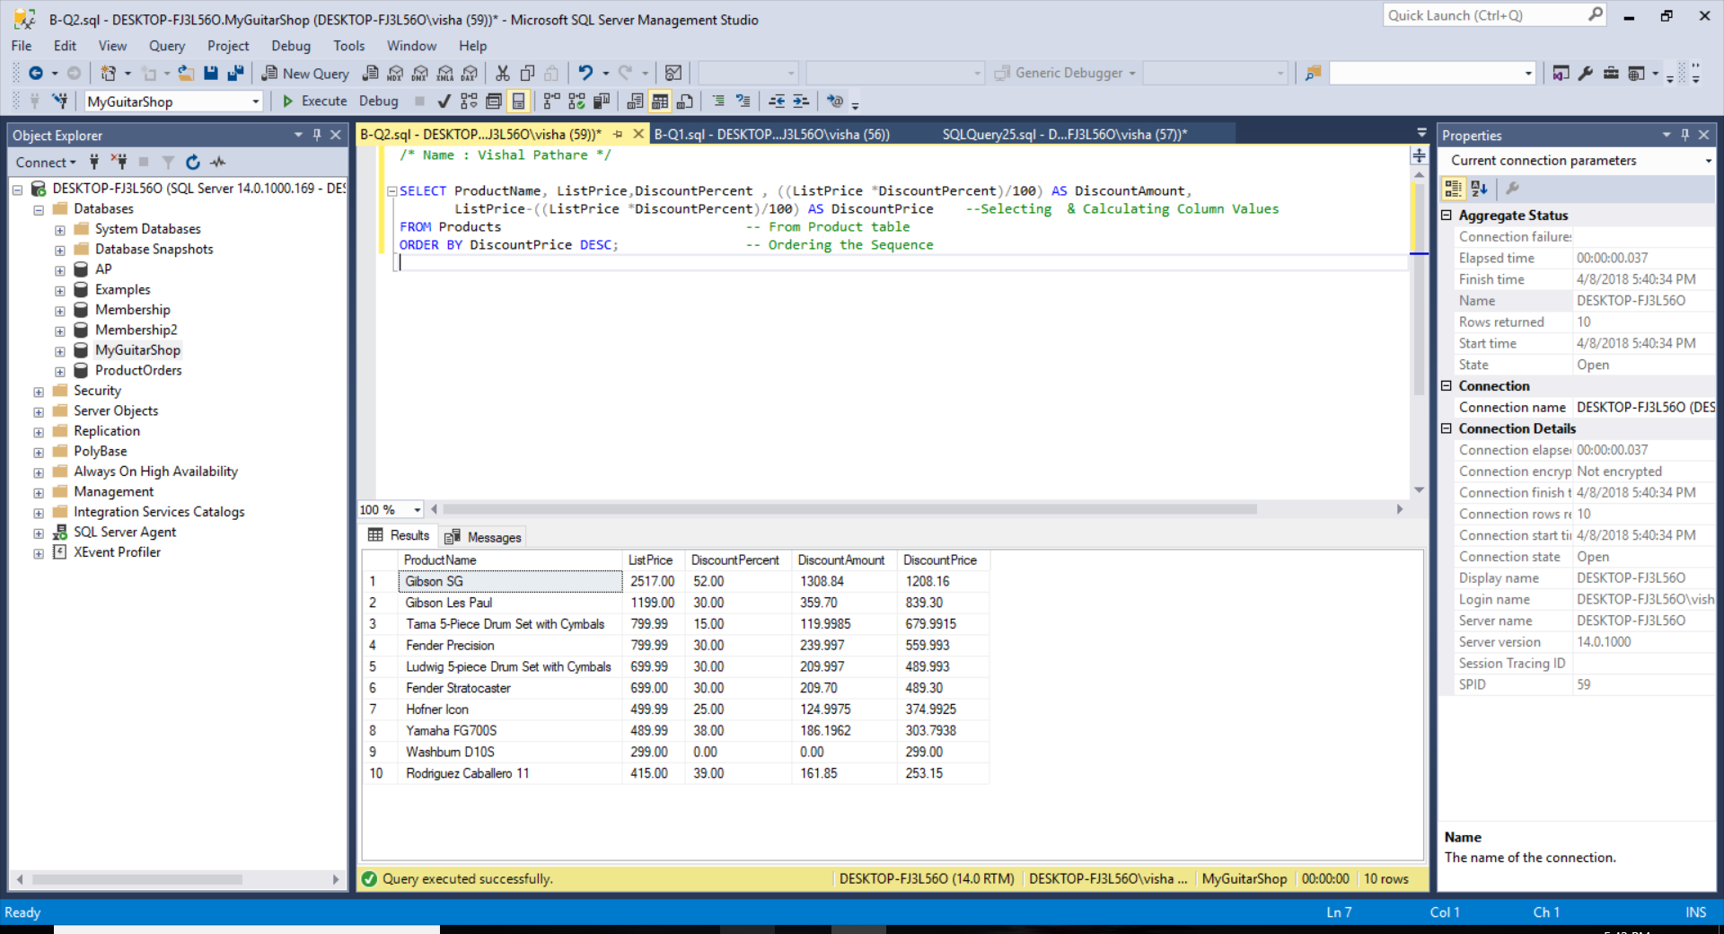

SELECT ProductName, ListPrice, DiscountPercent, ((ListPrice *DiscountPercent)/100) AS DiscountAmount,

ListPrice-((ListPrice *DiscountPercent)/100) AS DiscountPrice

FROM Products -- From Product table

ORDER BY DiscountPrice DESC; -- Ordering the Sequence

## The ESSENTIAL SQL SKILLS

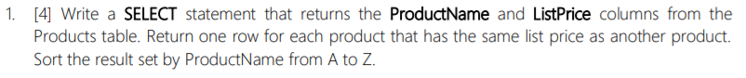

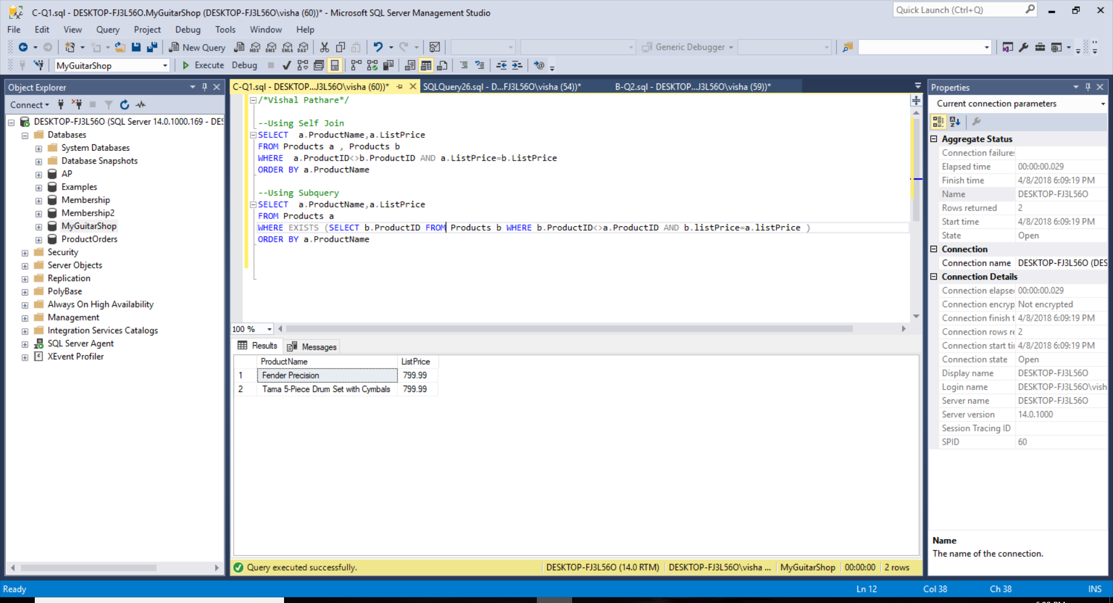

--Using Self Join

SELECT a.ProductName,a.ListPrice

FROM Products a, Products b

WHERE a.ProductID<>b.ProductID AND a.ListPrice=b.ListPrice

ORDER BY a.ProductName;

--Using Subquery

SELECT a.ProductName, a.ListPrice

FROM Products a

WHERE EXISTS (SELECT b.ProductID FROM Products b WHERE b.ProductID<>a.ProductID AND b.listPrice=a.listPrice)

ORDER BY a.ProductName;

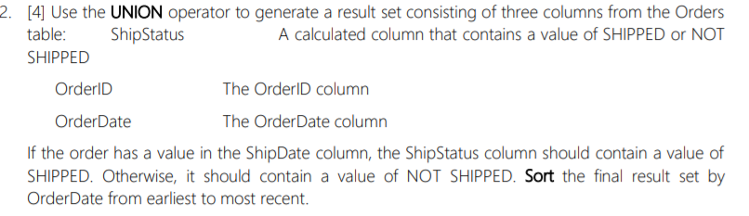

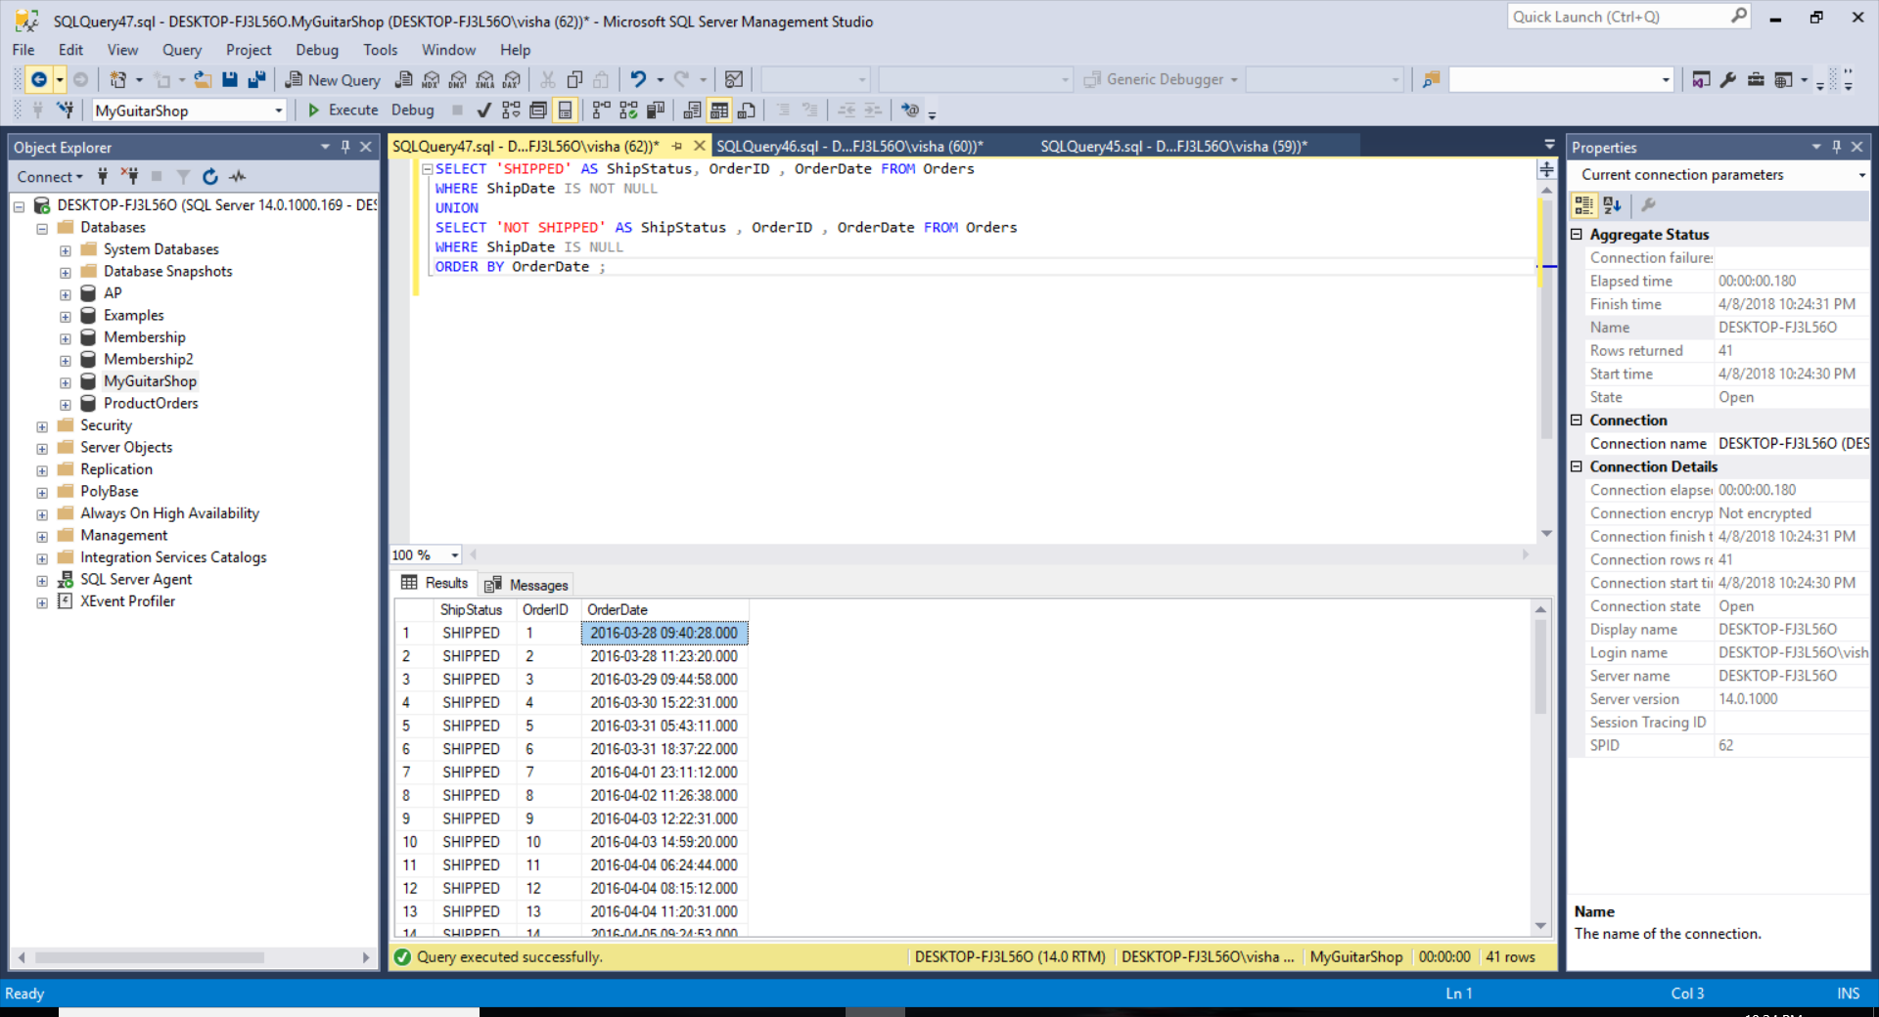

SELECT 'SHIPPED' AS ShipStatus, OrderID, OrderDate FROM Orders

WHERE ShipDate IS NOT NULL

UNION

SELECT 'NOT SHIPPED' AS ShipStatus, OrderID, OrderDate FROM Orders

WHERE ShipDate IS NULL

ORDER BY OrderDate;

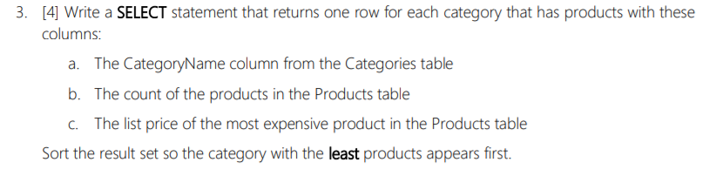

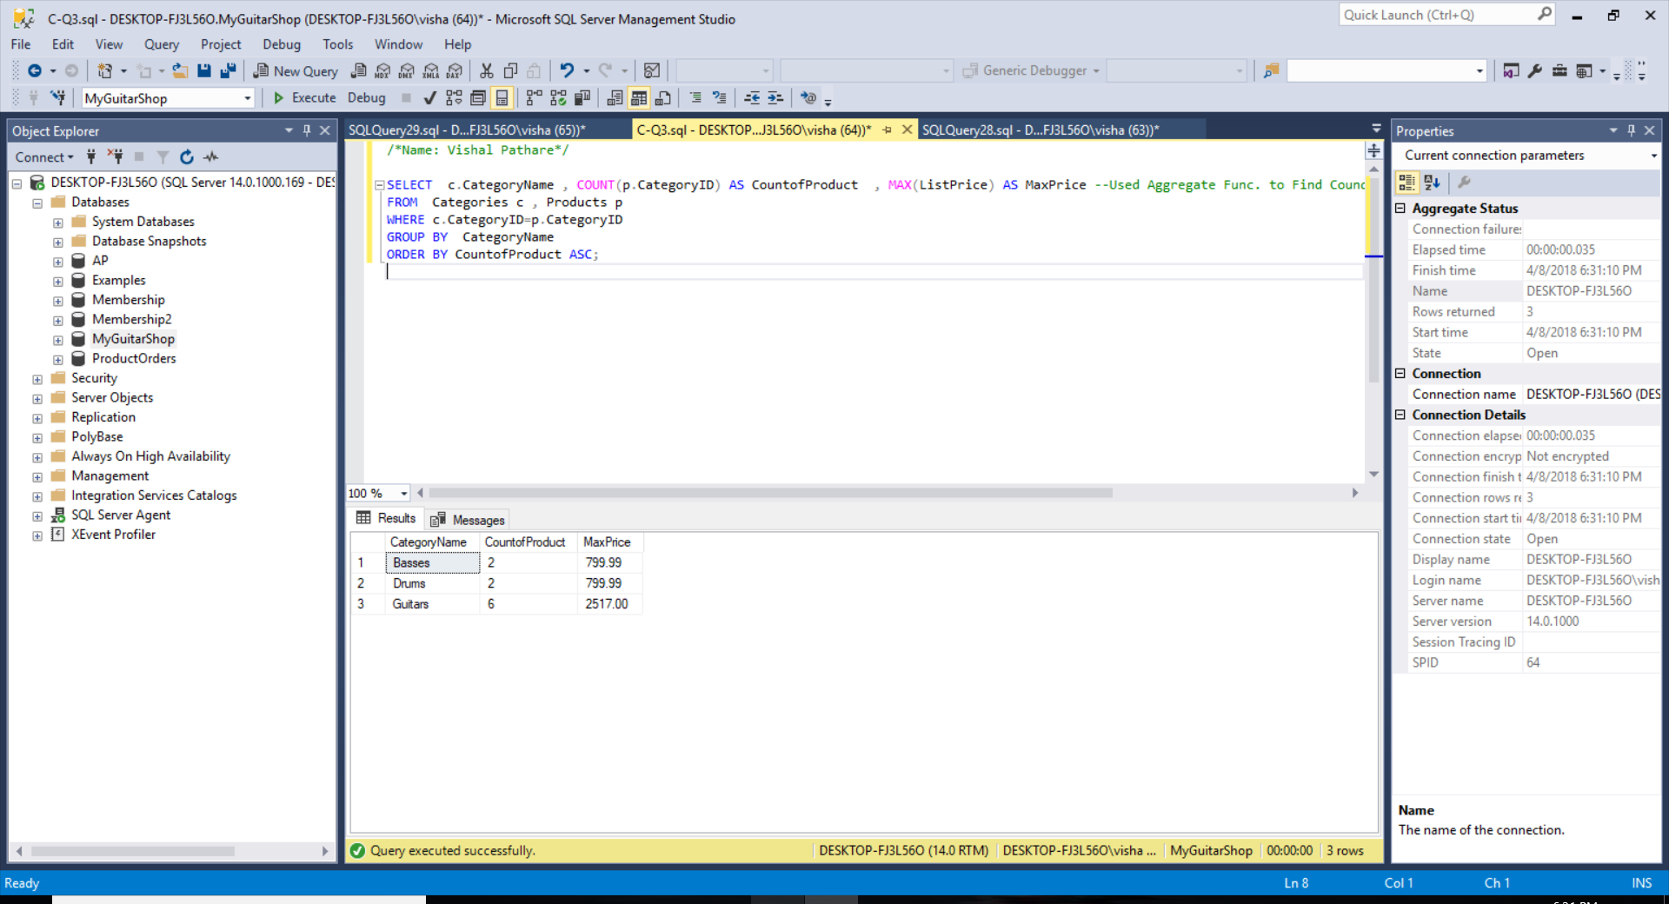

SELECT c.CategoryName, COUNT(p.CategoryID) AS CountofProduct, MAX(ListPrice) AS MaxPrice

FROM Categories c, Products p

WHERE c.CategoryID=p.CategoryID

GROUP BY CategoryName

ORDER BY CountofProduct ASC;

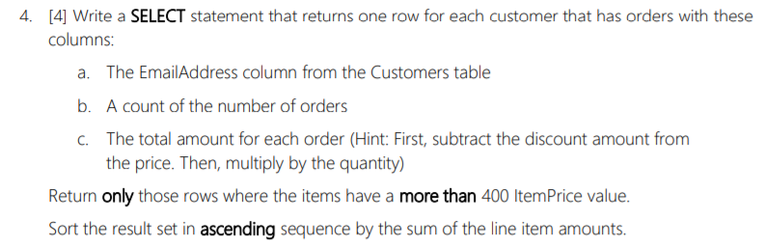

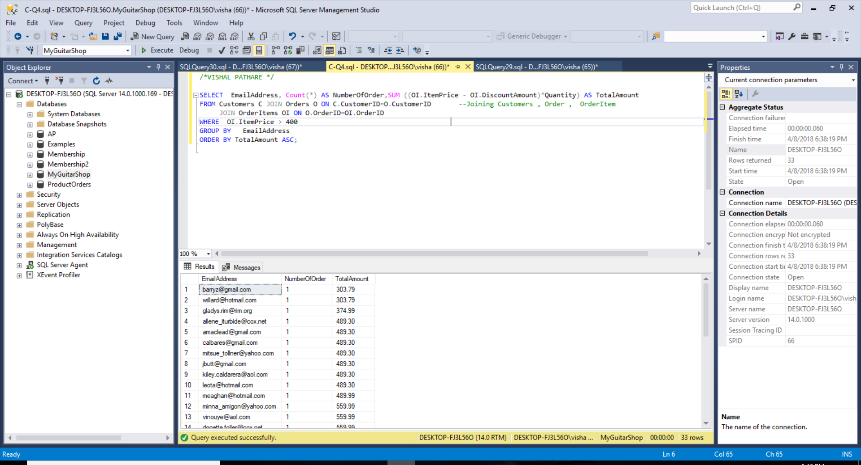

SELECT EmailAddress, Count(*) AS NumberOfOrder, SUM((OI.ItemPrice - OI.DiscountAmount)*Quantity) AS TotalAmount

FROM Customers C JOIN Orders O ON C.CustomerID=O.CustomerID

JOIN OrderItems OI ON O.OrderID=OI.OrderID

WHERE OI.ItemPrice > 400

GROUP BY EmailAddress

ORDER BY TotalAmount ASC;

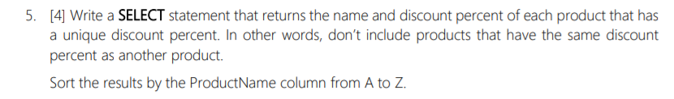

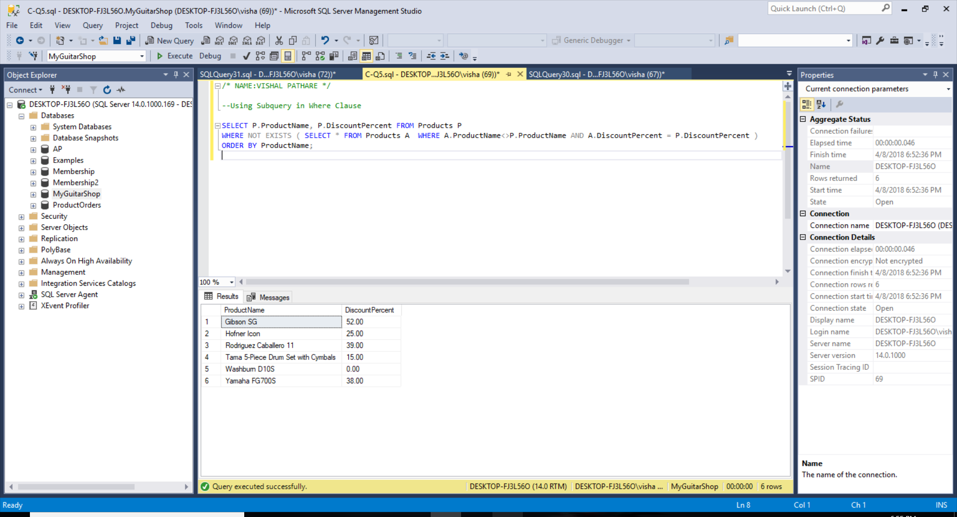

--Using Subquery in Where Clause

SELECT P.ProductName, P.DiscountPercent

FROM Products P

WHERE NOT EXISTS (SELECT * FROM Products A WHERE A.ProductName<>P.ProductName AND A.DiscountPercent = P.DiscountPercent )

ORDER BY ProductName;

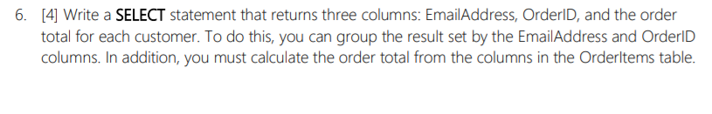

A:

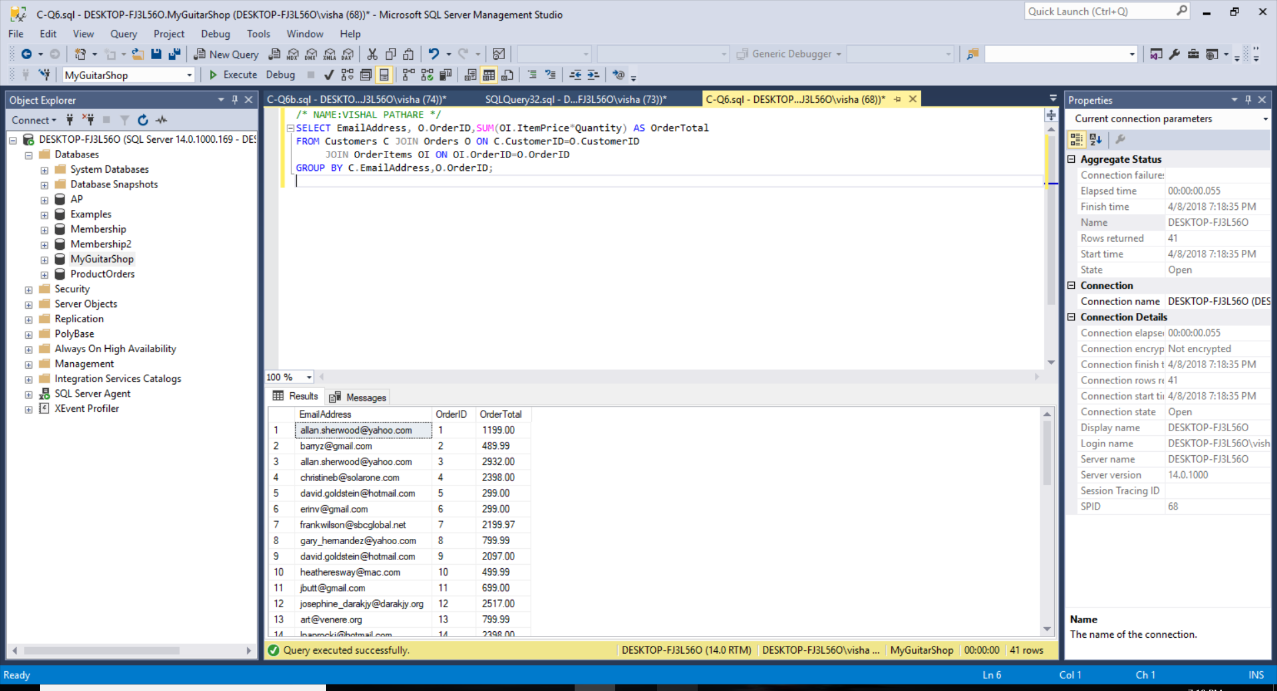

SELECT EmailAddress, O.OrderID, SUM(OI.ItemPrice*Quantity) AS OrderTotal

FROM Customers C JOIN Orders O ON C.CustomerID=O.CustomerID

JOIN OrderItems OI ON OI.OrderID=O.OrderID

GROUP BY C.EmailAddress, O.OrderID;

(B):

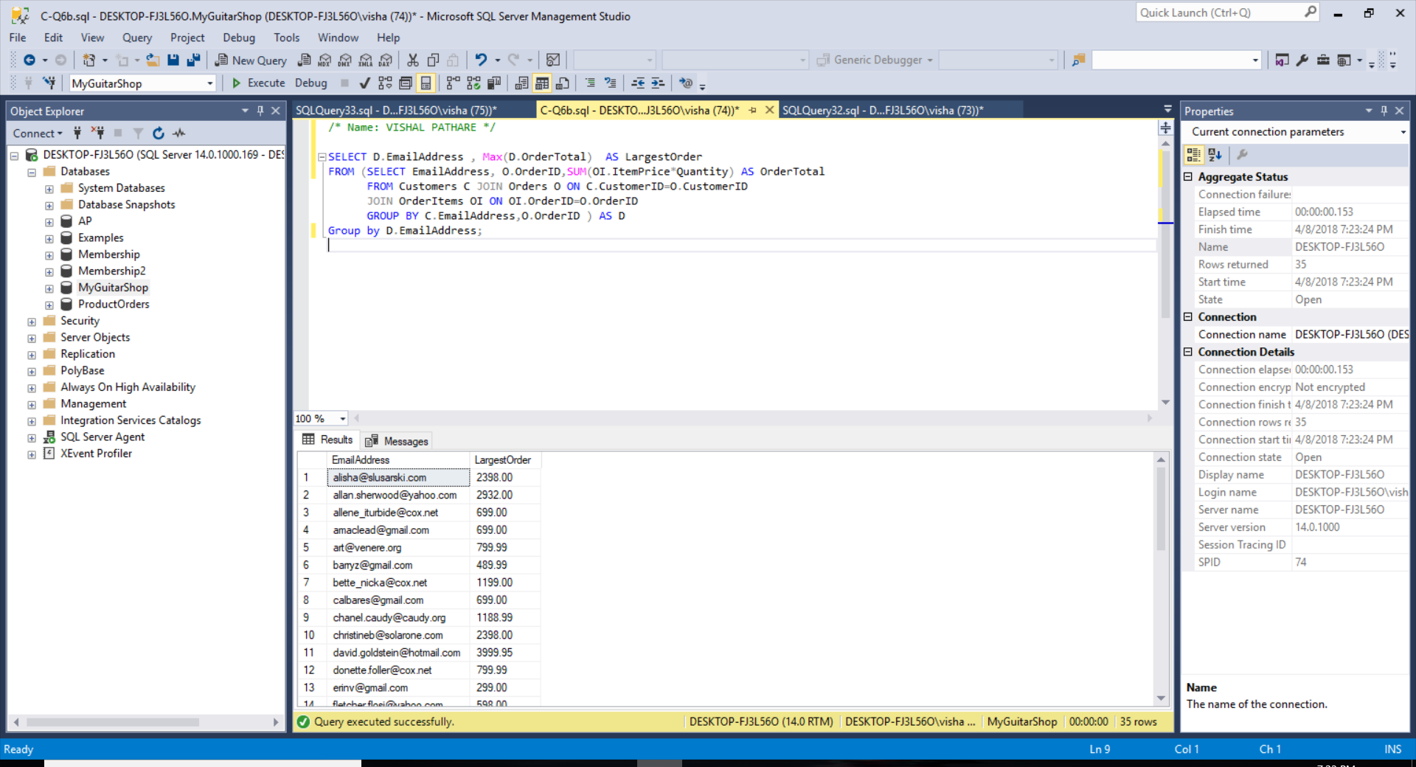

SELECT D.EmailAddress, Max(D.OrderTotal) AS LargestOrder

FROM (SELECT EmailAddress, O.OrderID, SUM(OI.ItemPrice*Quantity) AS OrderTotal

FROM Customers C JOIN Orders O ON C.CustomerID=O.CustomerID

JOIN OrderItems OI ON OI.OrderID=O.OrderID

GROUP BY C.EmailAddress,O.OrderID ) AS D

Group by D.EmailAddress;

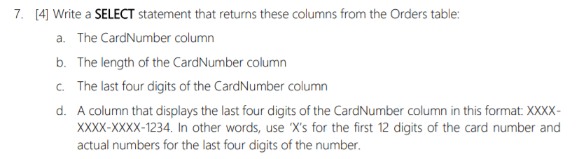

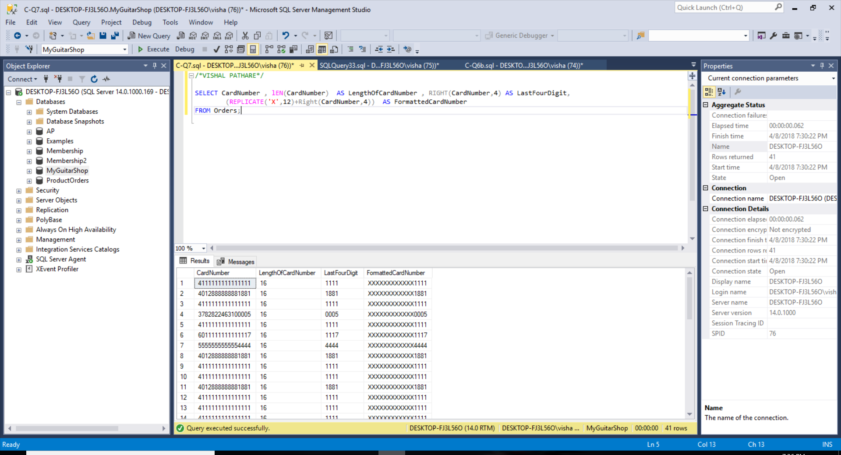

SELECT CardNumber, lEN(CardNumber) AS LengthOfCardNumber, RIGHT(CardNumber,4) AS LastFourDigit, (REPLICATE('X',12) + Right(CardNumber,4)) AS FormattedCardNumber

FROM Orders;

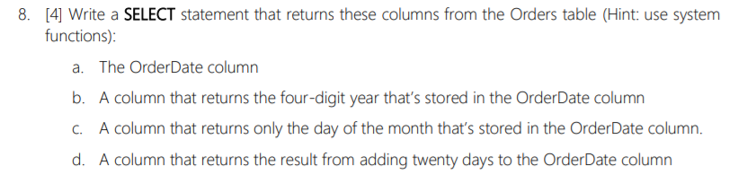

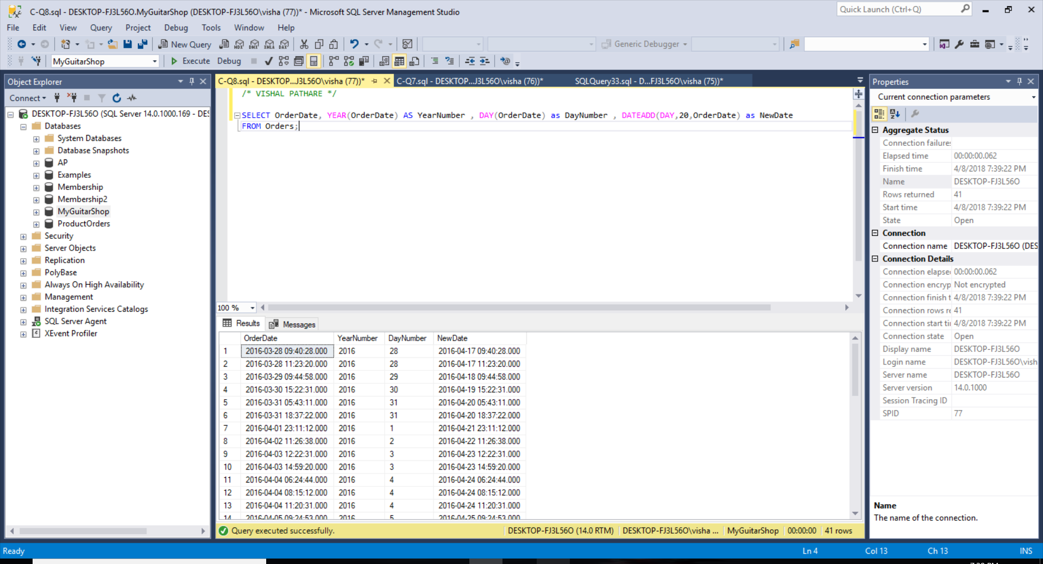

SELECT OrderDate, YEAR(OrderDate) AS YearNumber, DAY(OrderDate) as DayNumber, DATEADD (DAY,20, OrderDate) as NewDate

FROM Orders;

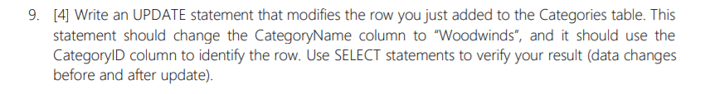

*Table before Updation:*

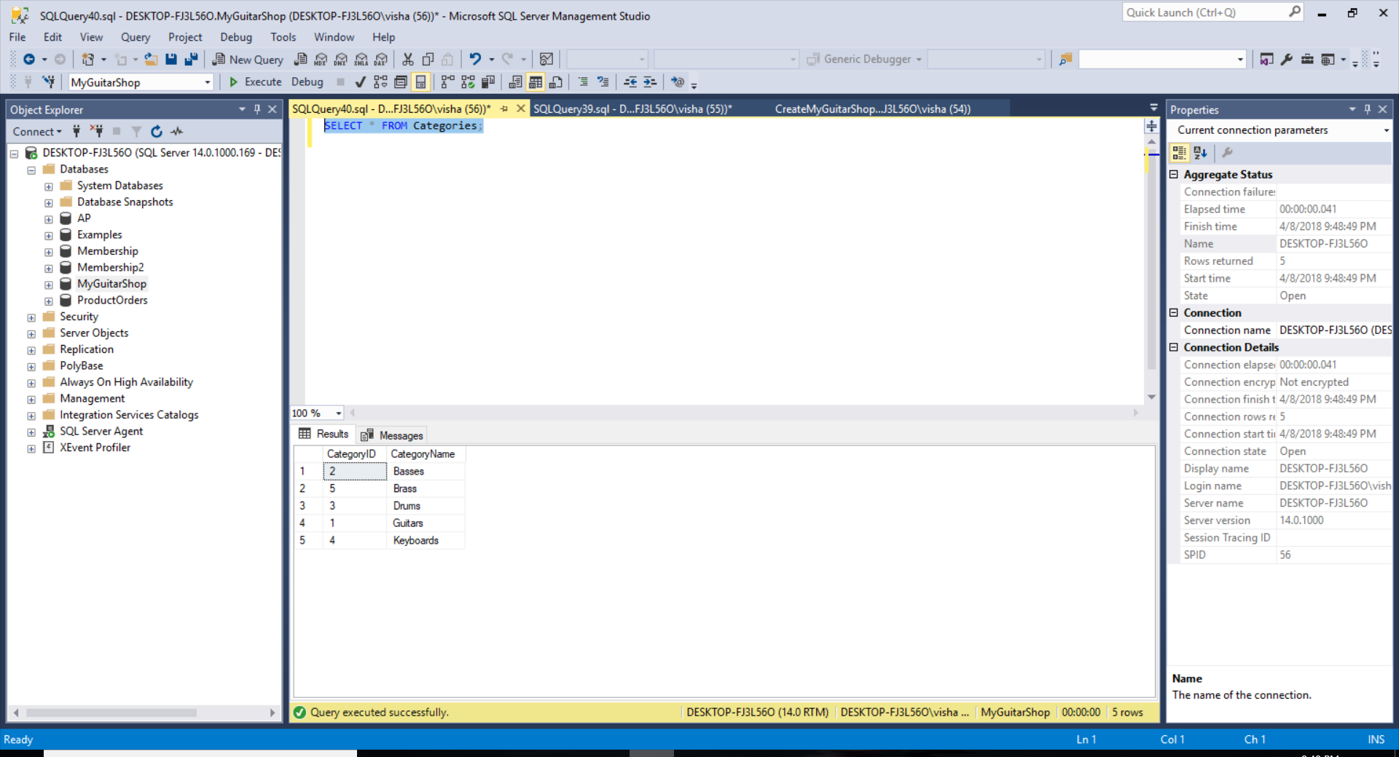

*Query Execution*

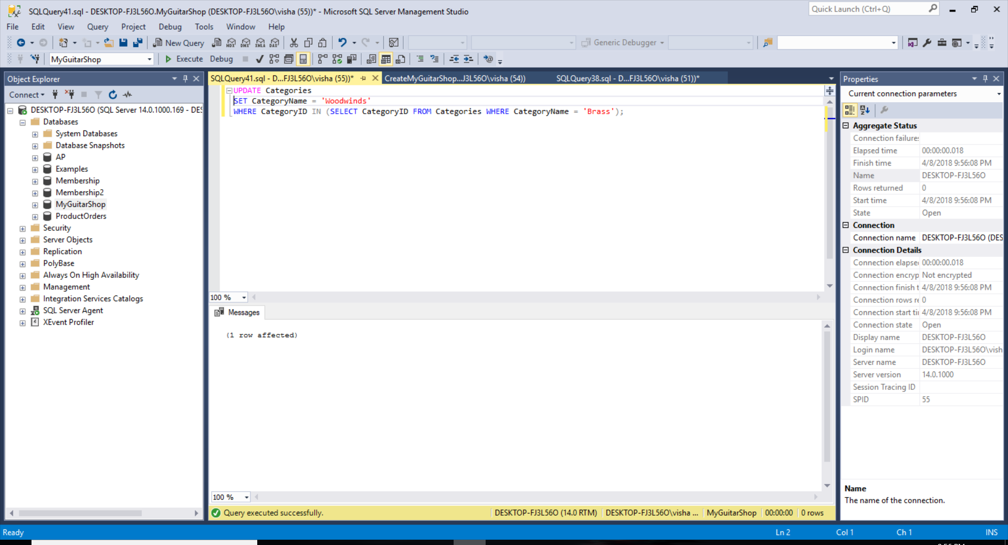

*Table After Updation:*

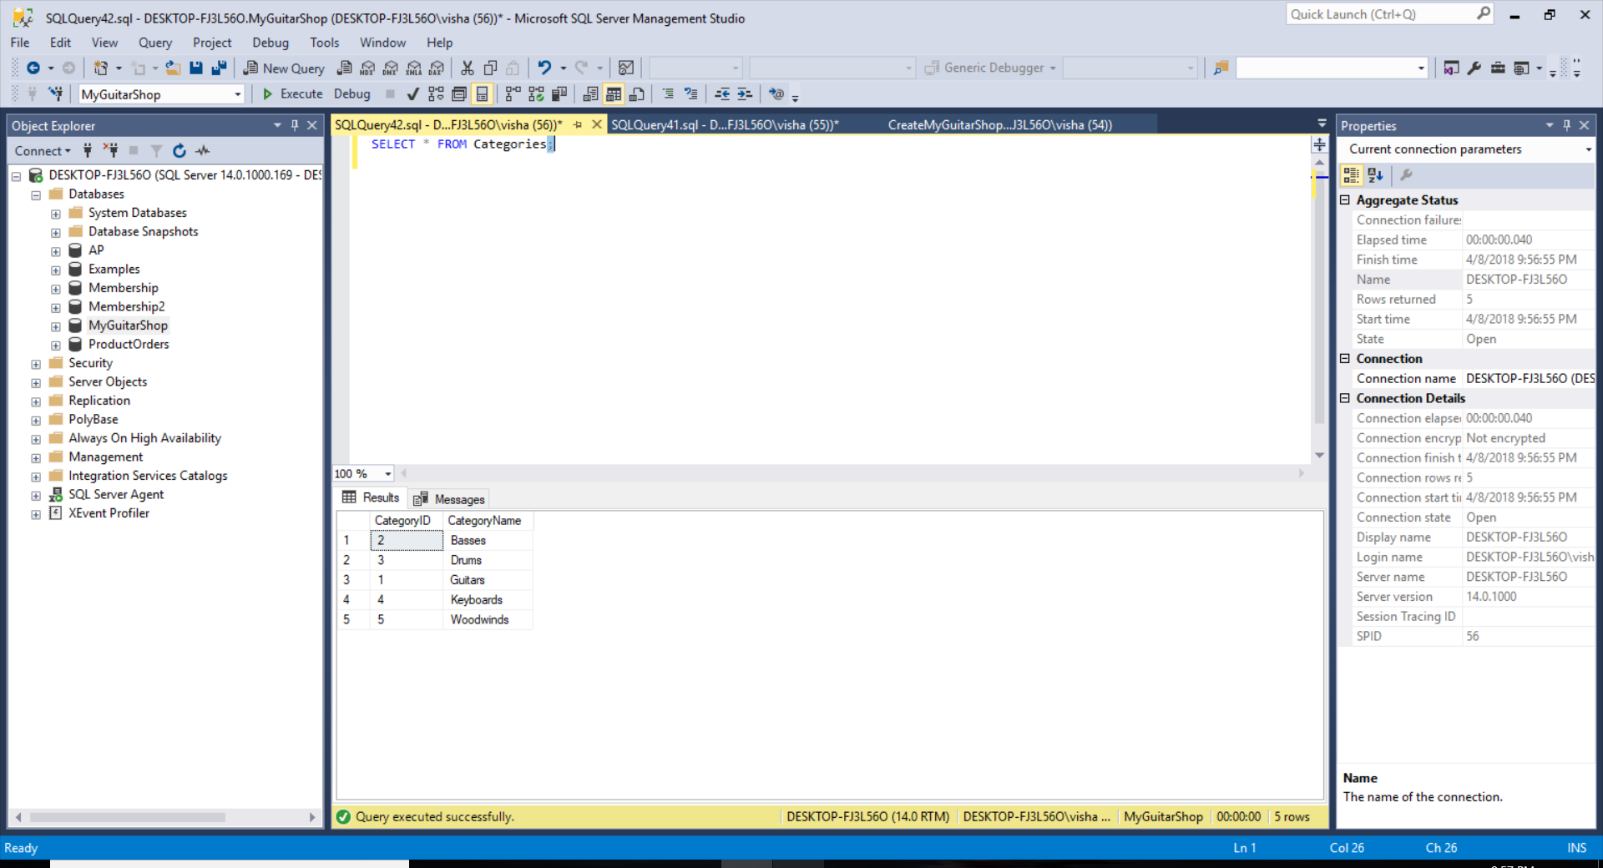

UPDATE Categories

SET CategoryName = 'Woodwinds'

WHERE CategoryID IN (SELECT CategoryID FROM Categories WHERE CategoryName = 'Brass');

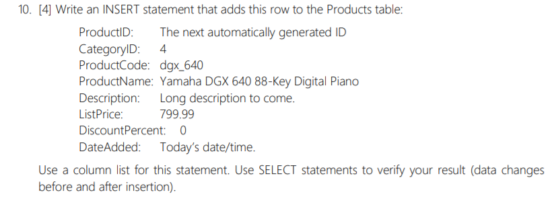

*Table before Updation:*

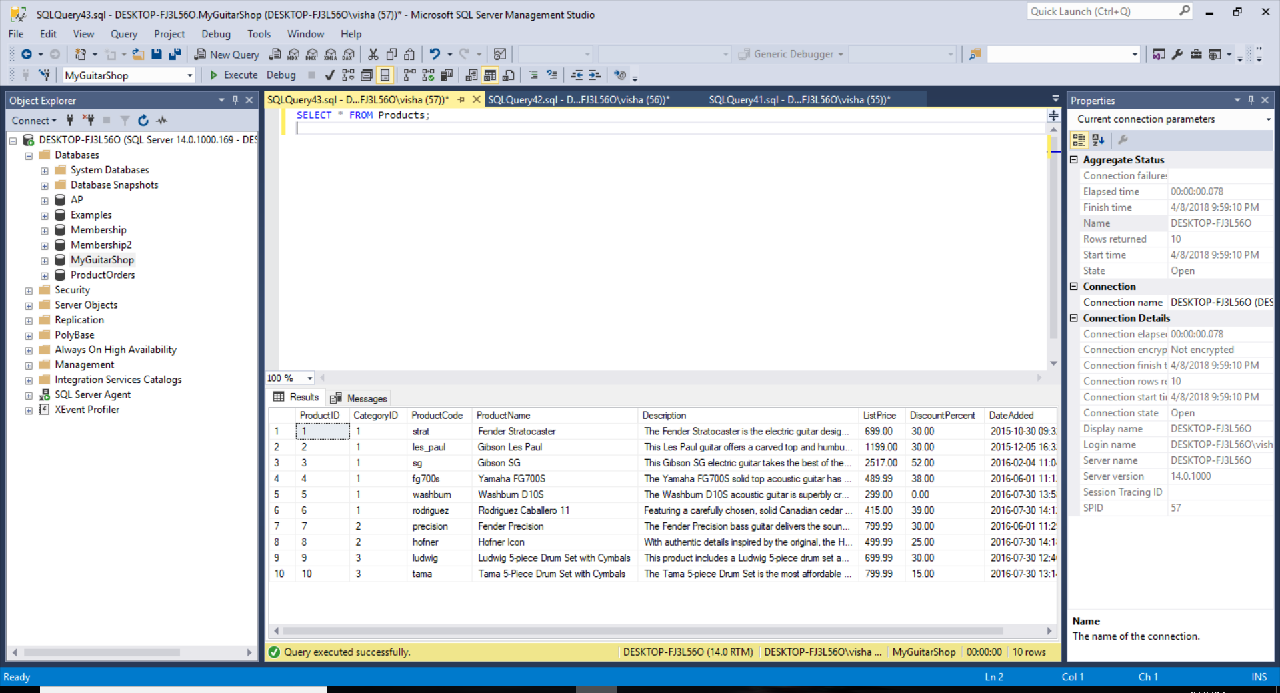

*Query Execution*

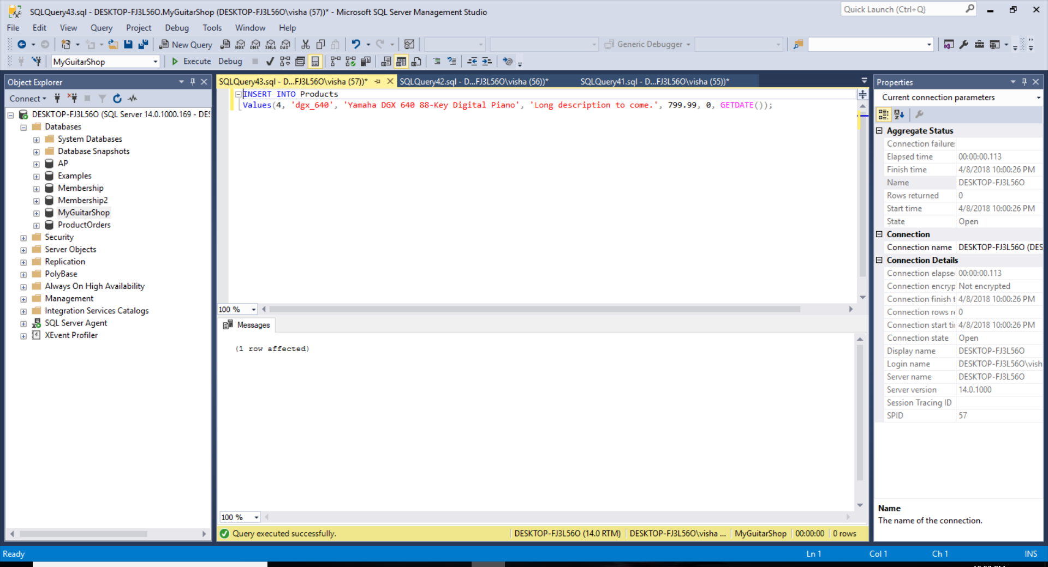

*Table After Updation:*

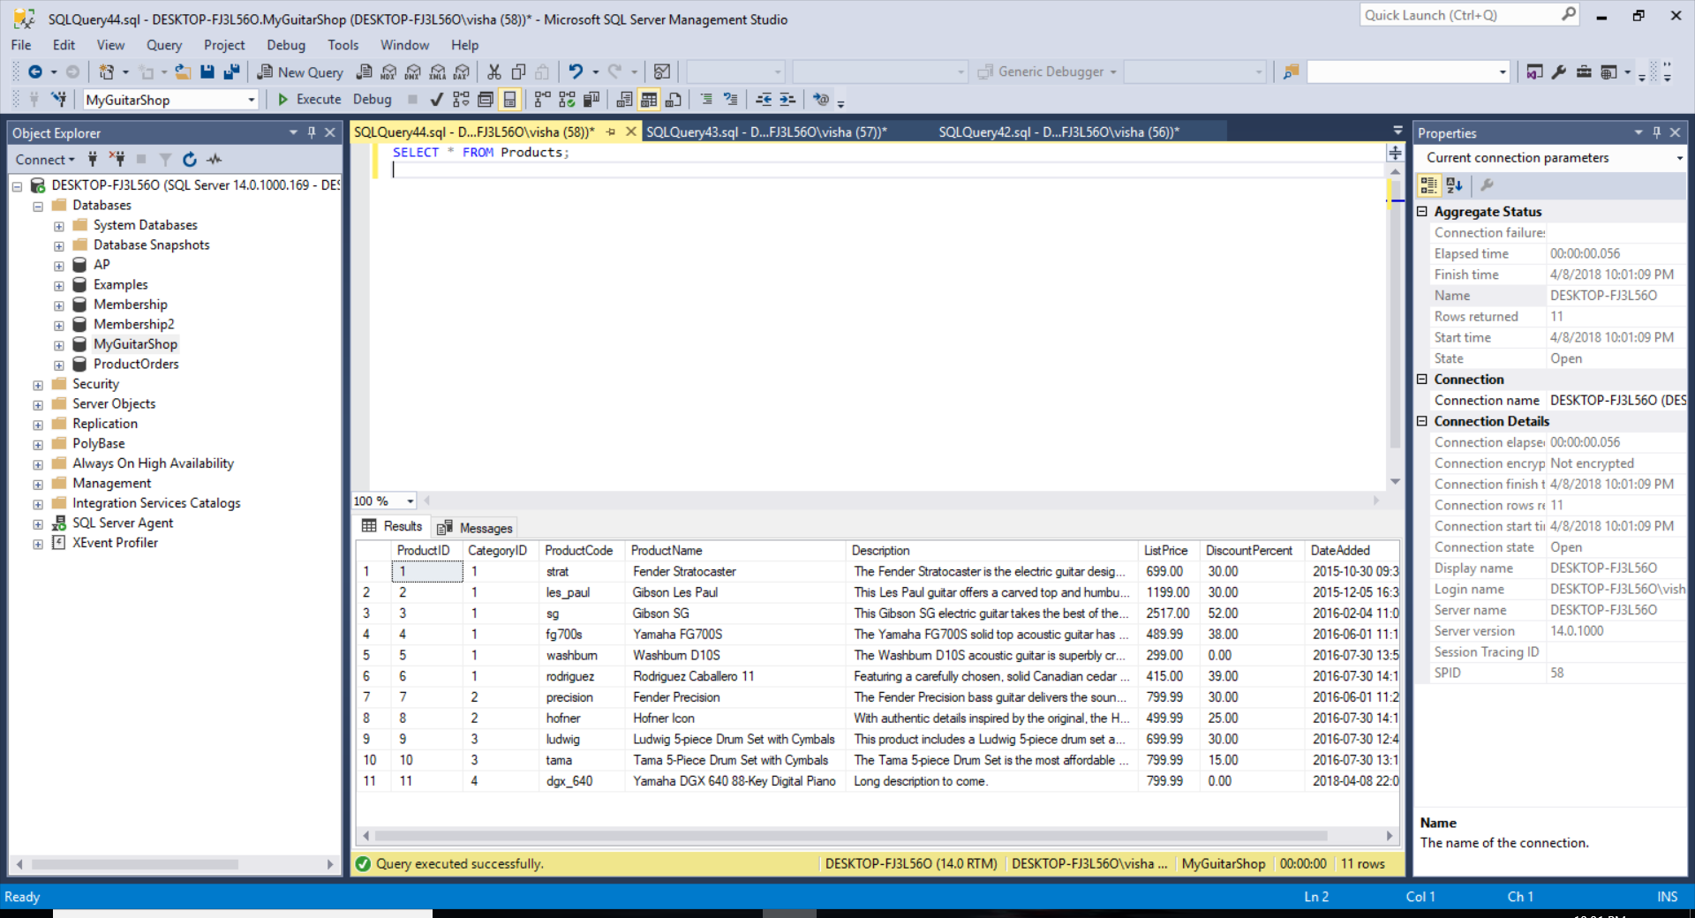

INSERT INTO Products

Values(4, 'dgx_640', 'Yamaha DGX 640 88-Key Digital Piano', 'Long description to come.', 799.99, 0, GETDATE());

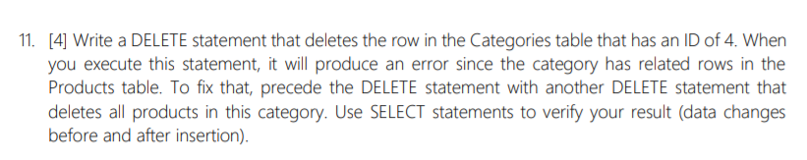

*Table before Updation:*

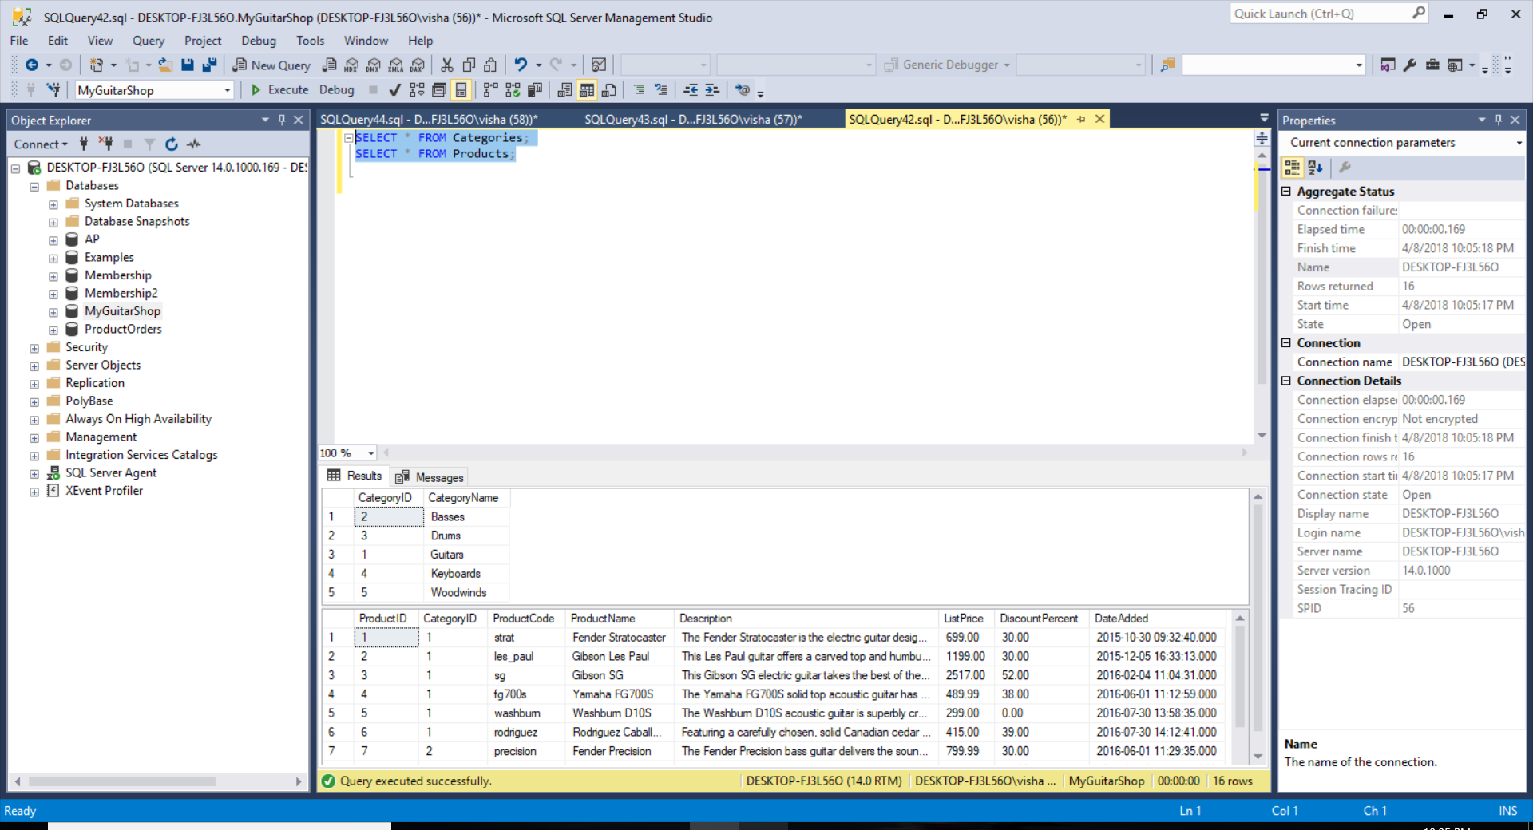

*Query Execution*

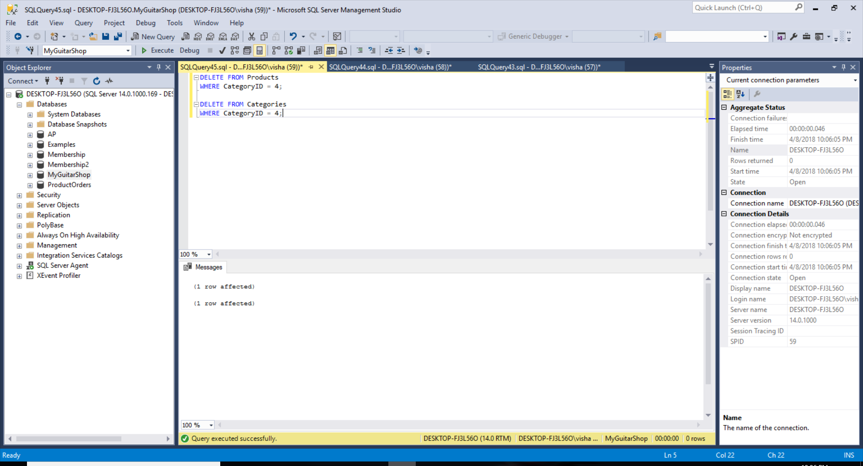

*Table After Updation:*

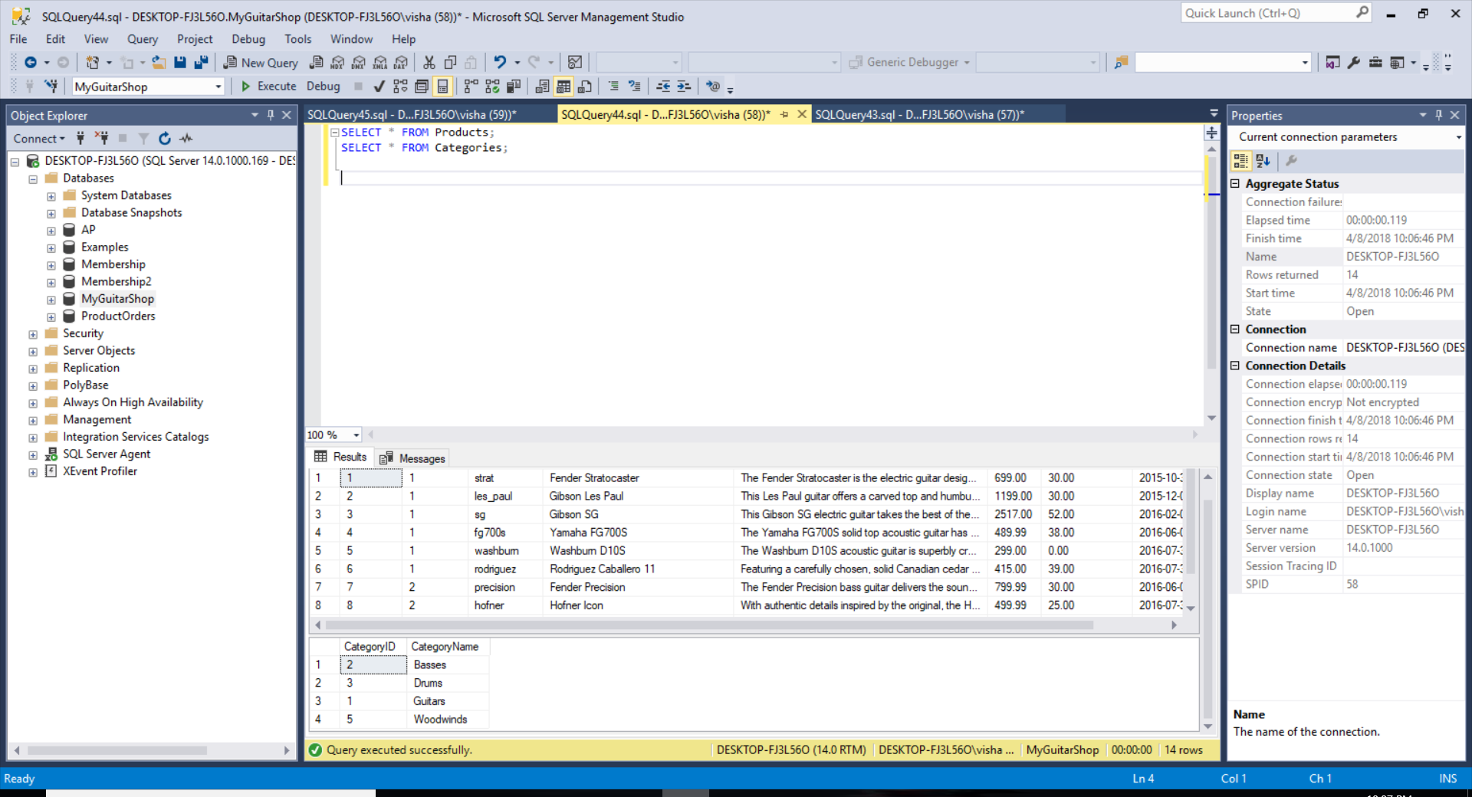

DELETE FROM Products

WHERE CategoryID = 4;

DELETE FROM Categories

WHERE CategoryID = 4;

## Advanced SQL SKILLS

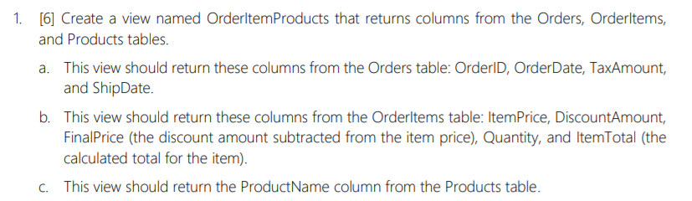

*View Query Execution:*

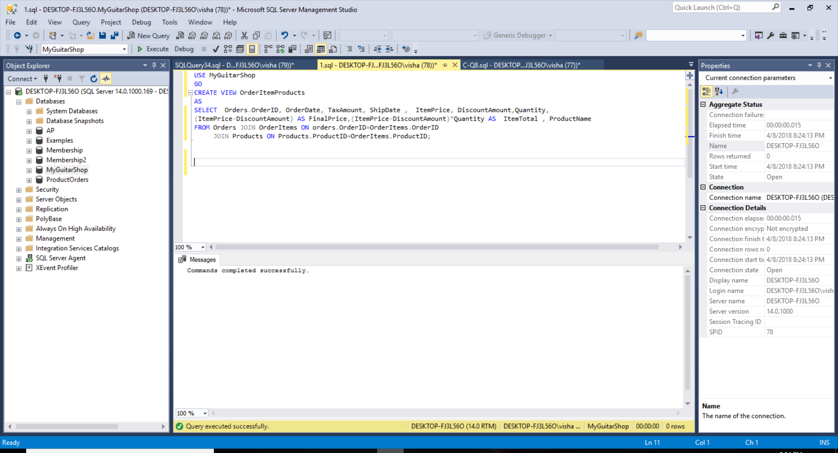

*Data In View:*

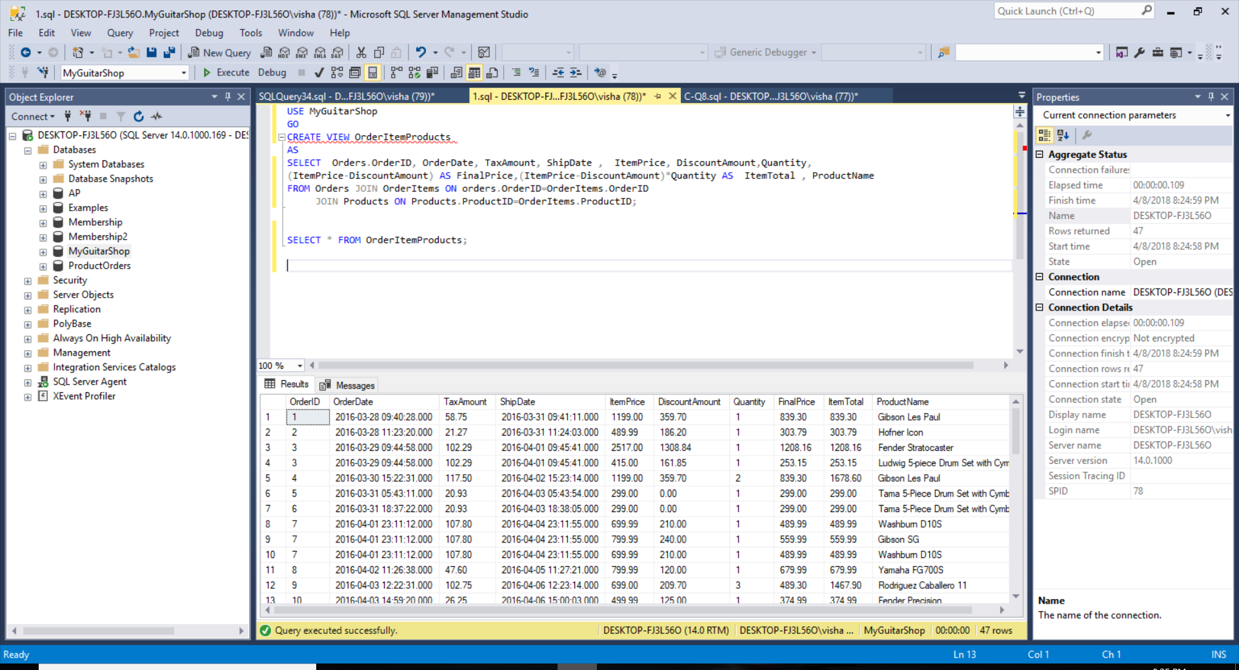

USE MyGuitarShop

GO

CREATE VIEW OrderItemProducts

AS

SELECT Orders.OrderID, OrderDate, TaxAmount, ShipDate, ItemPrice, DiscountAmount, Quantity, (ItemPrice-DiscountAmount) AS FinalPrice, (ItemPrice-DiscountAmount)*Quantity AS ItemTotal, ProductName

FROM Orders JOIN OrderItems ON orders.OrderID=OrderItems.OrderID JOIN Products ON Products.ProductID=OrderItems.ProductID;

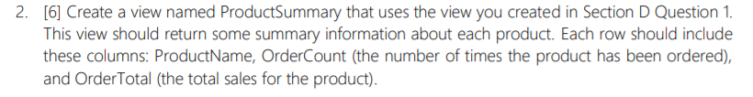

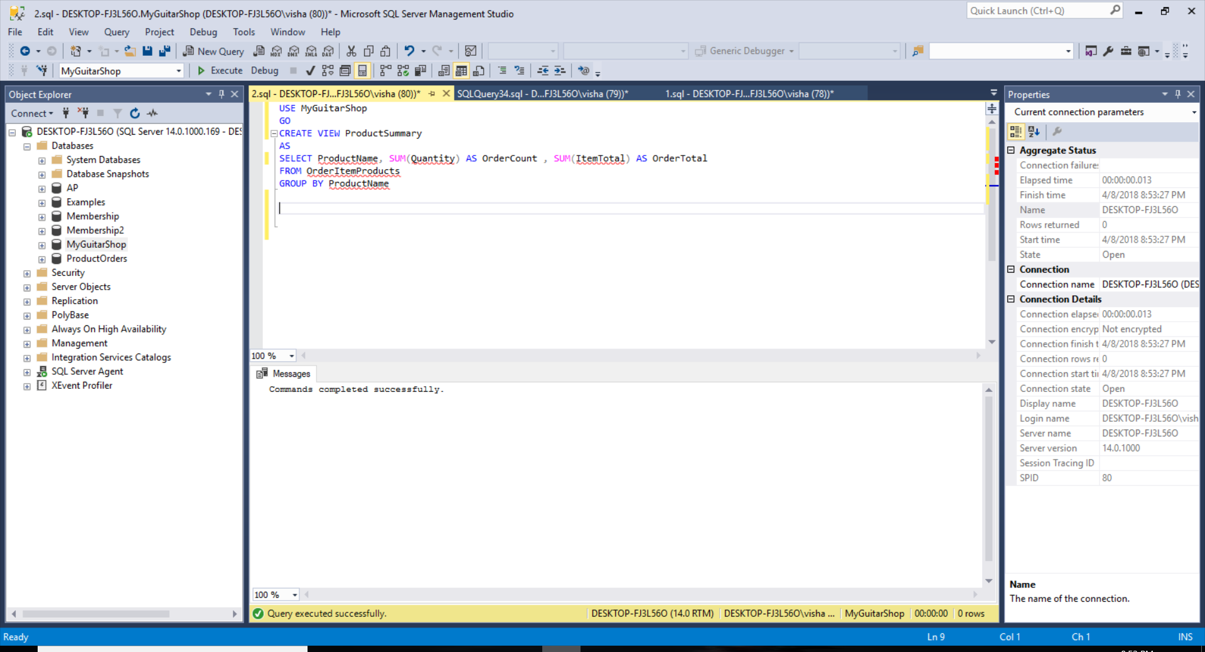

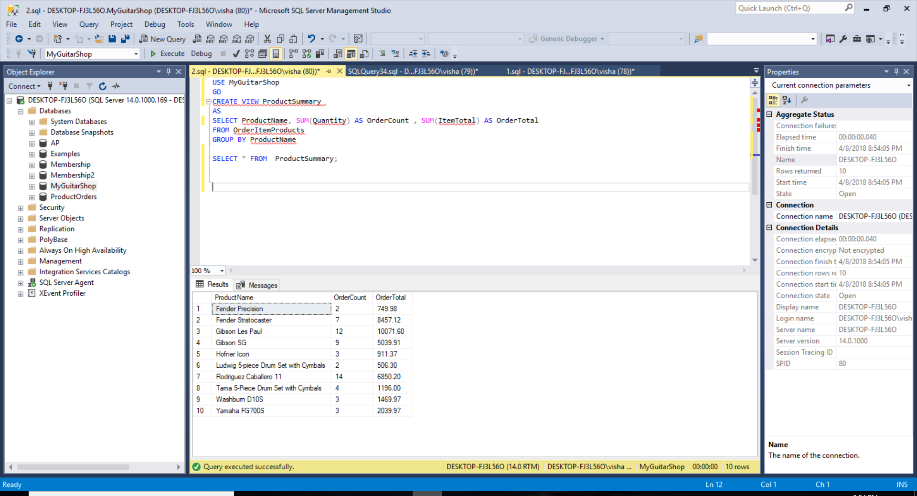

USE MyGuitarShop

GO

CREATE VIEW ProductSummary

AS

SELECT ProductName, SUM(Quantity) AS OrderCount, SUM(ItemTotal) AS OrderTotal

FROM OrderItemProducts

GROUP BY ProductName;

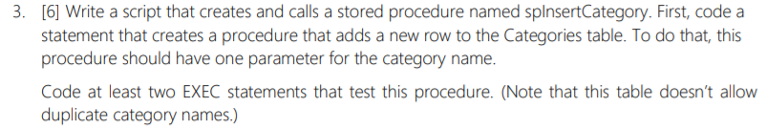

*Procedure Query Execution:*

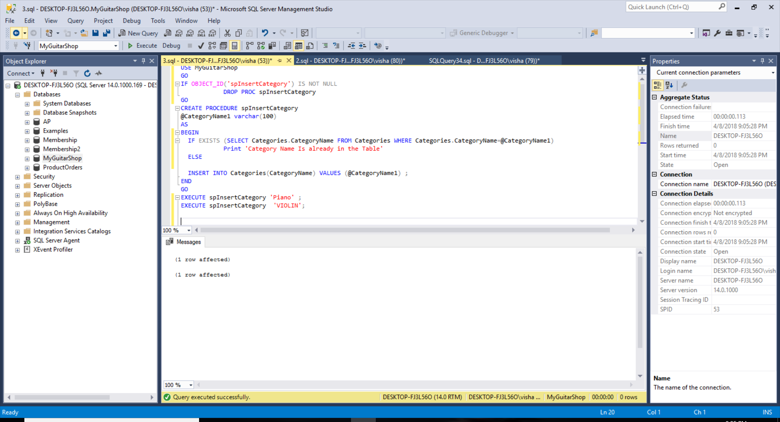

*Data in Categories Table After Execution:*

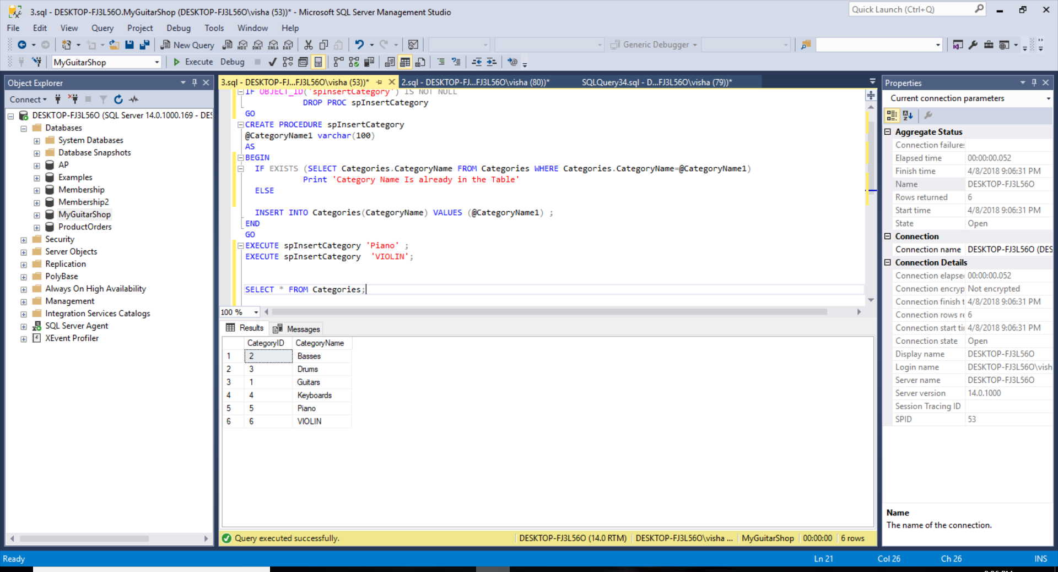

IF OBJECT_ID('spInsertCategory') IS NOT NULL

DROP PROC spInsertCategory

GO

CREATE PROCEDURE spInsertCategory

@CategoryName1 varchar(100)

AS

BEGIN

IF EXISTS (SELECT Categories.CategoryName FROM Categories WHERE Categories.CategoryName=@CategoryName1)

Print 'Category Name Is already in the Table'

ELSE

INSERT INTO Categories(CategoryName) VALUES (@CategoryName1);

END

GO

EXECUTE spInsertCategory 'Piano';

EXECUTE spInsertCategory 'VIOLIN';

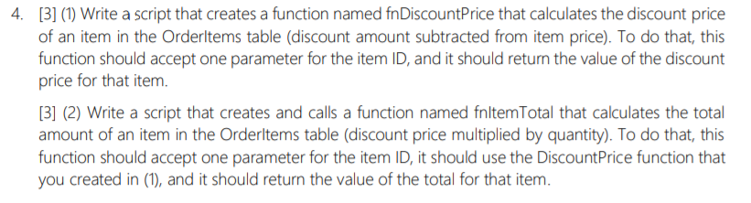



*Function fnDiscountPrice Execution:*

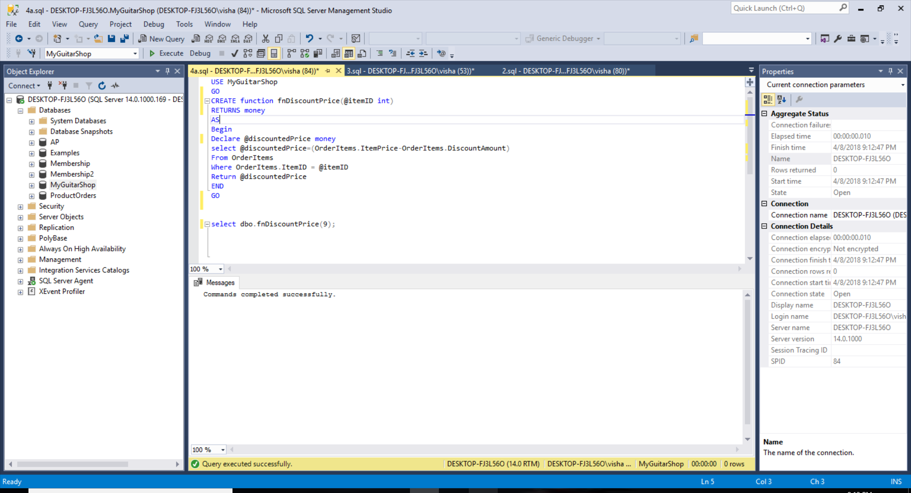

*Checking Result for Itemid:1 =*

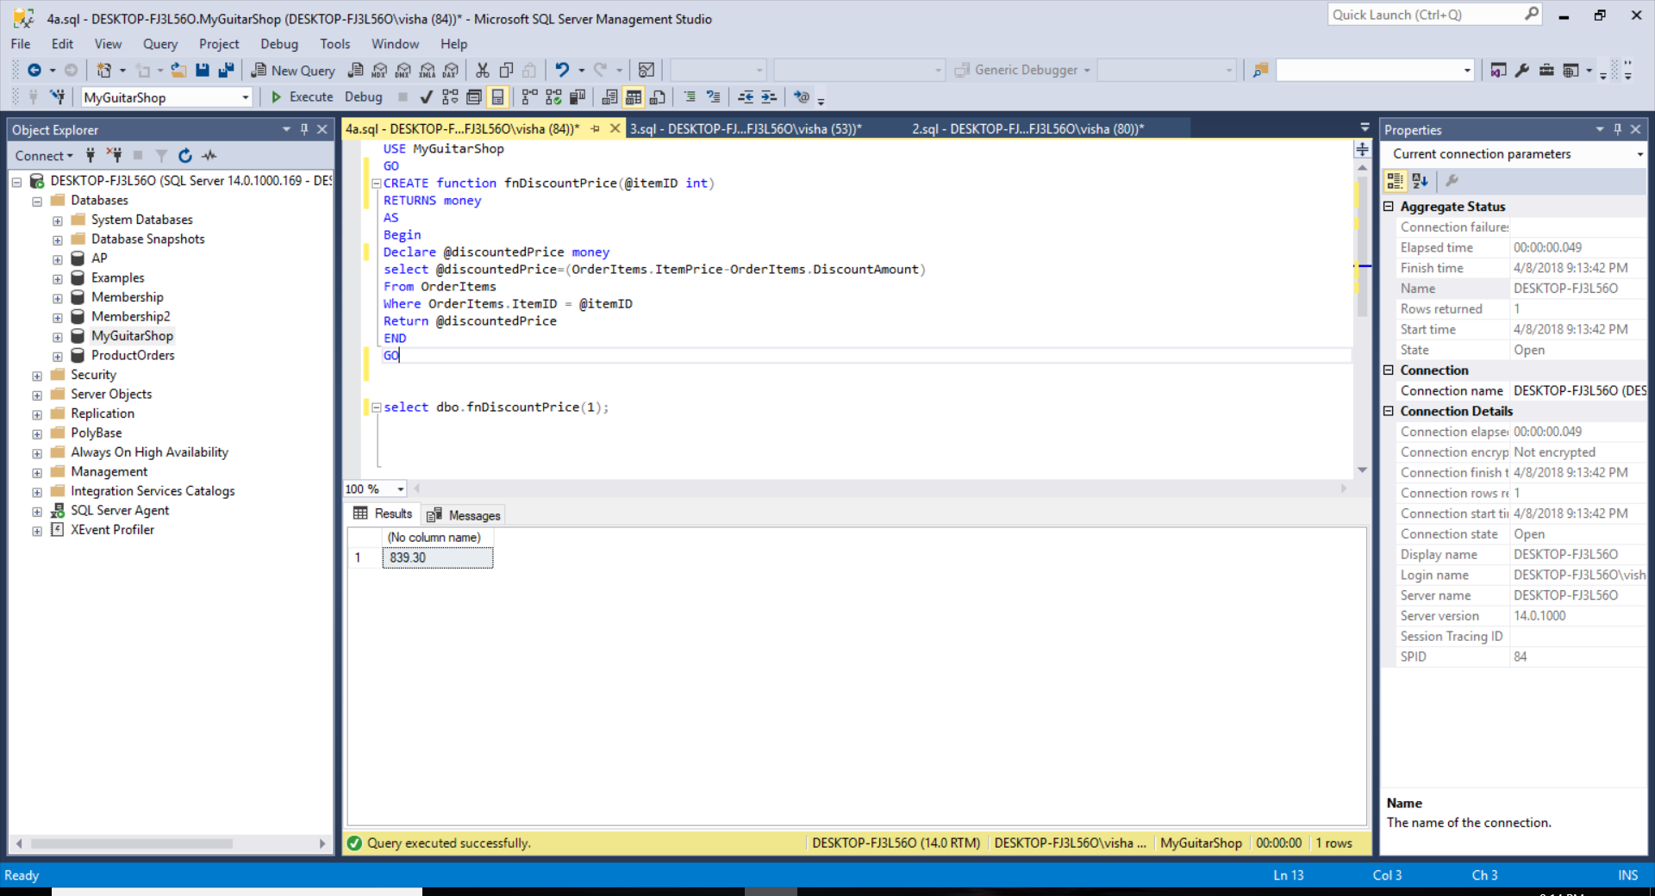

USE MyGuitarShop

GO

CREATE function fnDiscountPrice(@itemID int)

RETURNS money

AS

Begin

Declare @discountedPrice money

select @discountedPrice=(OrderItems.ItemPrice-OrderItems.DiscountAmount)

From OrderItems

Where OrderItems.ItemID = @itemID

Return @discountedPrice

END

GO

1. *Function fnItemTotal Execution:*

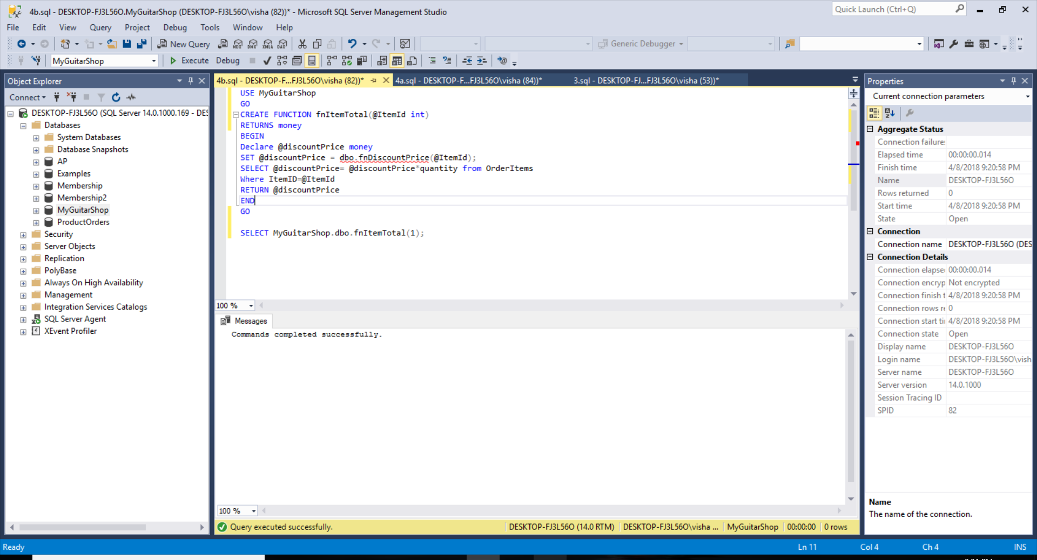

*Checking Result for ItemID:5 =*

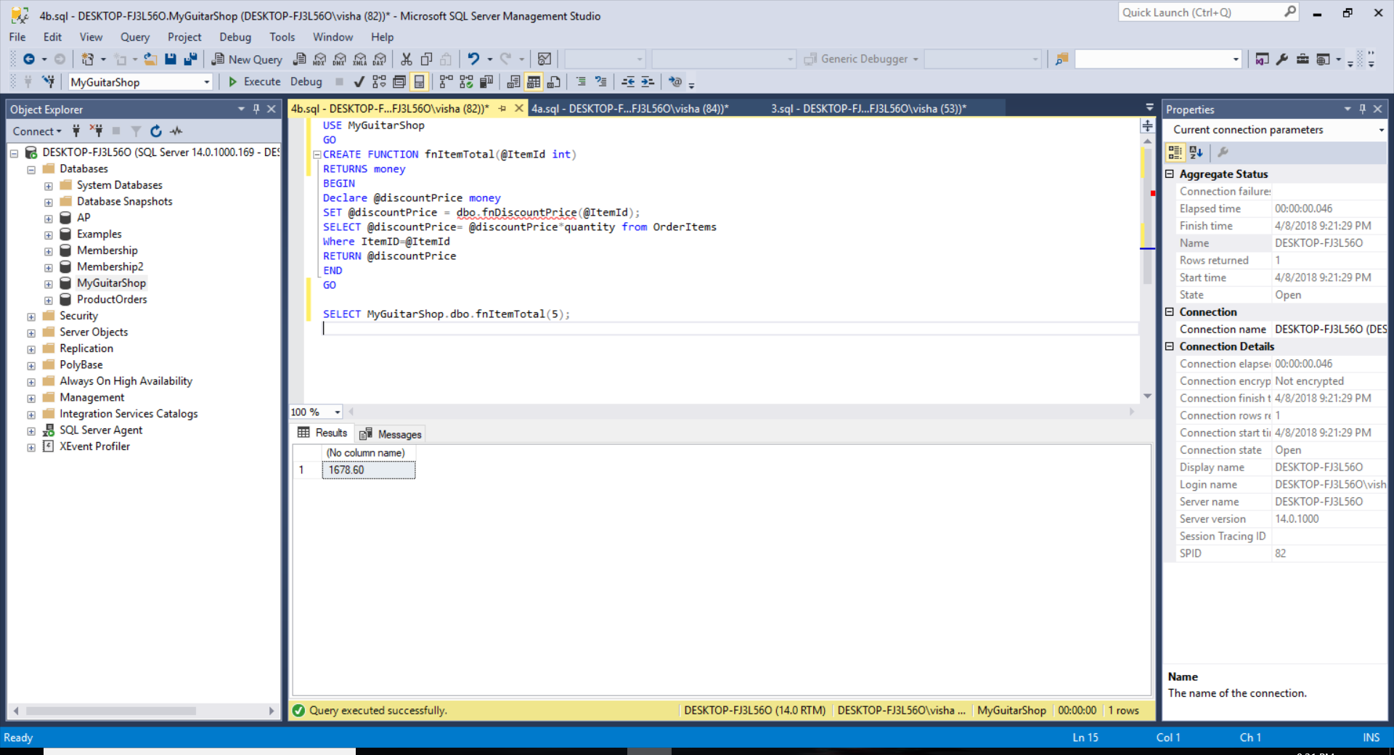

USE MyGuitarShop

GO

CREATE FUNCTION fnItemTotal(@ItemId int)

RETURNS money

BEGIN

Declare @discountPrice money

SET @discountPrice = dbo.fnDiscountPrice(@ItemId);

SELECT @discountPrice= @discountPrice*quantity from OrderItems

Where ItemID=@ItemId

RETURN @discountPrice

END

GO

## DataBASE DEsIGN

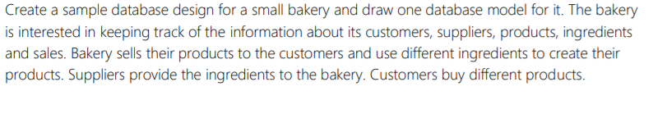



**A:**

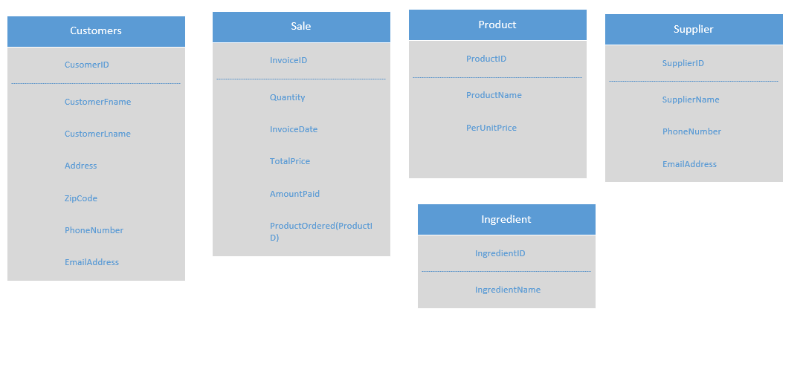

FINAL DESIGN: (INCLUDING TABLE RELATIONSHIP, PRIMARY AND FOREIGN KEY )

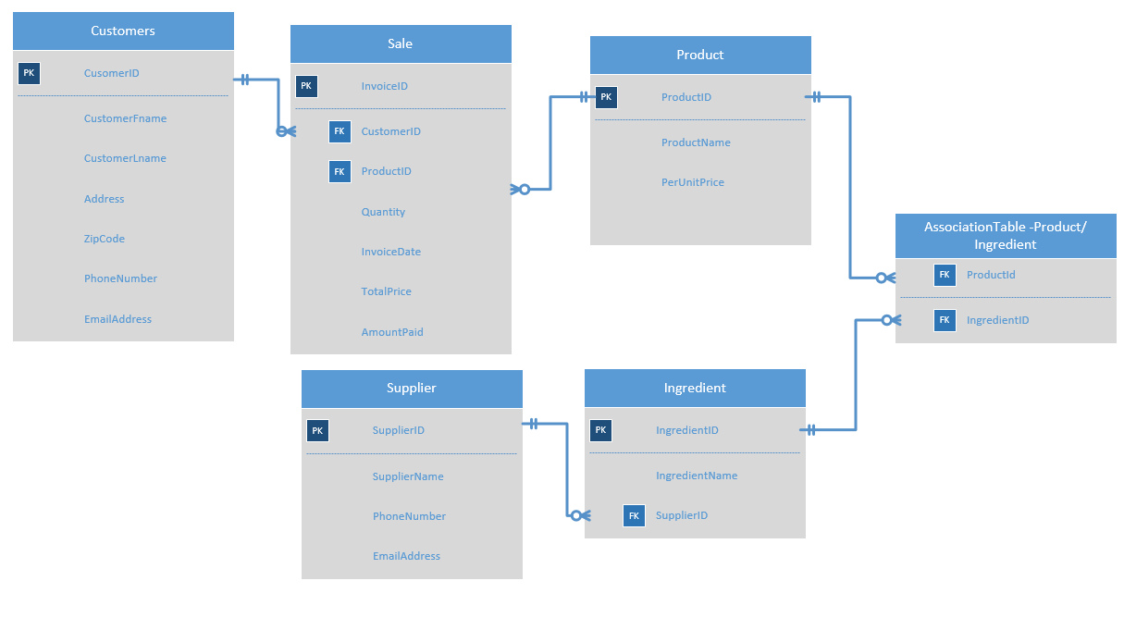



|  |  |  |  |  |  |  |
| --- | --- | --- | --- | --- | --- | --- |
| TABLE NAME | COLUMNS | | KEY (PRIMAY/FOREIGN) | | DATATYPE | NULLABILITIES |
| Customer | CustomerID | | Primary | | INT | NOTNULL |
| CustomerFname | |  | | VARCHAR | NOTNULL |
| CustomerLName | |  | | VARCHAR | NOTNULL |
| Address | |  | | VARCHAR | NOTNULL |
| ZipCode | |  | | VARCHAR | NOTNULL |
| PhoneNumber | |  | | VARCHAR | NOTNULL |
| EmailAddress | |  | | VARCHAR | DEFAULNULL |
| Sale | InvoiceID | Primary | | INT | | NOTNULL |
| CustomerID | Foreign | | INT | | NOTNULL |
| ProductID | Foreign | | INT | | NOTNULL |
| Quantity |  | | INT | | NOTNULL |
| InvoiceDate |  | | DATETIME | | NOTNULL |
| TotalPrice |  | | MONEY | | NOTNULL |
| AmountPaid |  | | MONEY | | NOTNULL |
| Product | ProductID | Primary | | INT | | NOTNULL |
| ProductName |  | | VARCHAR | | NOTNULL |
| PerUnitPrice |  | | MONEY | | NOTNULL |
| Ingredient | IngredientID | Primary | | INT | | NOTNULL |
| IngredientName |  | | VARCHAR | | NOTNULL |
| SupplierID | Foreign | | INT | | NOTNULL |
| Association Table (Product/Ingredient) | productID | Foreign | | INT | | NOTNULL |
| IngredientID | Foreign | | INT | | NOTNULL |
| Supplier | SupplierID | Primary | | INT | | NOTNULL |
| SupplierName |  | | VARCHAR | | NOTNULL |
| PhoneNumber |  | | VARCHAR | | NOTNULL |
| EmailAddress |  | | VARCHAR | | DEFAULTNULL |

Table Relationship:

* Customers - Sale: One to Many Relationship

A customer Can place many Orders that’s why relation between Customers and sale is One-Many

* Product – Sale: One to many

A product can have multiple order by the same customer or different customer so relation between product and sale is One to many.

* Product – Ingredient: Many to Many

One product can have multiple ingredient and one ingredient can be part of multiple product so relation between these two table is many to many.

To resolve this we have added Association table (Junction table) into the database and form one to many relation with junction table from product and ingredient.

* Supplier - Ingredient: One to Many:

Assuming the base case that, one supplier can supply multiple ingredient and two suppliers can’t supply same ingredient, we can form one to many relations between these two table.





This Final Design is Designed into its 3rd normal Form.

1NF: In first normal form, I removed columns which contain repeating values. For example, for customers table I combined address1 and address2 columns as Address. And also made sure that each column is scalar value column. So now, our final design does not contain columns with repeating values.

2NF: Here in our Final Design, all non-key columns in the tables are depend on their primary keys. For example, in customers table I have kept only that non-key column which gives us info about customers.

3NF: Database to be in 3NF, all non-key columns must be depend on Primary key and Table should not contain derived column. For example, Initially, in sell table I have added balance column which can be calculated form TotalPrice and AmountPaid, So in 3NF I discarded that column. Now in Our Final design all NON-KEY-Column are depend on primary key and there is no derived column.



I have designed this database Considering given scenario:

A customer can place many orders. An order should have customer detail and product details .i.e who place the order and what product he wants. So order (sale) table will take customer details from customer table using customerID and product details from Product table using productID. The Product is made up of multiple ingredients, also we can use one ingredient in different products so these two table form many to many relation respectively. That’s why i added association table(Junction table). Now product and ingredient form one to many relationships with junction table. Supplier supply the ingredients. Here I assumed on scenario that a supplier can supply many ingredient and form one to many relationship.

Table Relationship:

* Customers - Sale: One to Many Relationship

A customer Can place many Orders that’s why relation between Customers and sale is One-Many

* Product – Sale: One to many

A product can have multiple order by the same customer or different customer so relation between product and sale is One to many.

* Product – Ingredient: Many to Many

One product can have multiple ingredient and one ingredient can be part of multiple product so relation between these two table is many to many.

To resolve this we have added Association table (Junction table) into the database and form one to many relation with junction table from product and ingredient.

* Supplier - Ingredient: One to Many:

Assuming the base case that, one supplier can supply multiple ingredient and two suppliers can’t supply same ingredient, we can form one to many relations between these two table.

**REMARK:**

Project 1 helps me to enhance sql skills and knowledge in Following Section:

* Working with single table as well as multiple tables (Using Select)
* Code summary queries and subqueries
* Working with insert, Update, Delete statements
* Working with data types.

Project 1 also helpful to Understand Database Design Concepts. In addition to this, it helps to improve knowledge in following advance SQL concept:

* Working with view, script,
* Working with stored procedure, functions.